

**KANWAL SHEHZADI 02-131212-027**

FORMAL METHODS IN SOFTWARE ENGINEERING ASSIGNMENT 02



**TASK # 01:** Refer to the Document control system given in the book “The way of Z” by Jonathan Jacky, define the normal Checkin operation, and a total TCheckln operation that accounts for the exceptional cases in Document Control System.

**Checkin Operation**

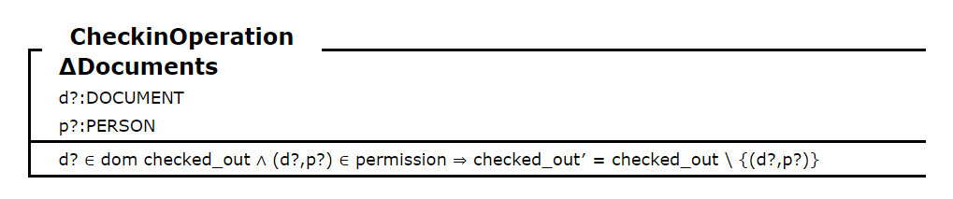

**TCheckIn Operation**

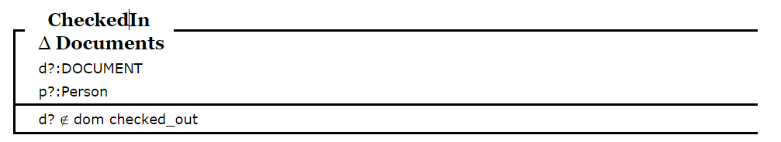

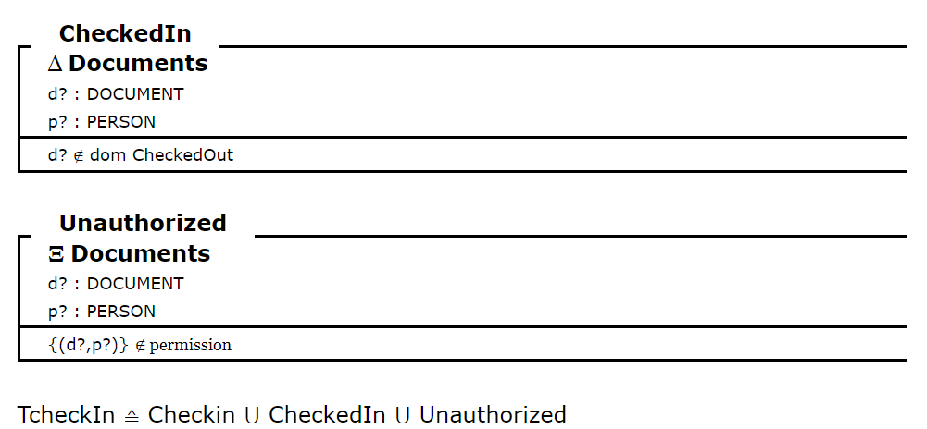

**TASK # 02:** Consider the following scenario based on air-traffic control system : The air-traffic control of an airport keeps a record of the planes waiting to land and the assignment of planes to gates on the ground. There are operations to accept a plane when it arrives in the airport’s waiting Space, to assign a plane to a gate at the airport and to record that a plane leaves its gate.

1. Arrival of plane ArriveTotal == Arrive ∨ ArriveErr Arrive records the arrival of a plane in the airport’s waiting area. The plane must be neither already waiting nor assigned to a gate.

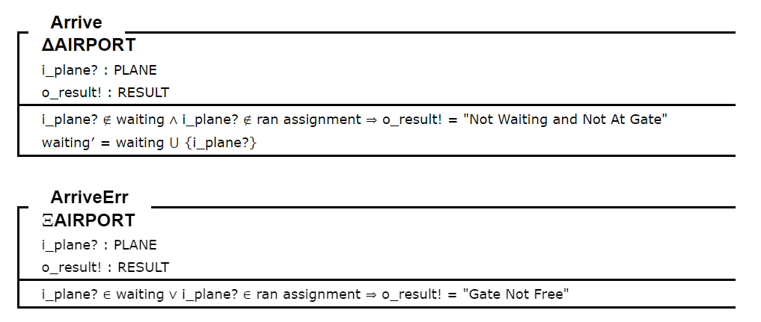

1. Assignment of plane AssignTotal == Assign ∨ AssignErr Assign records the assignment of a plane to a free gate. The plane must be waiting and the gate must be free. The pairing between gate and plane is added to assignment. Plane is removed from waiting.

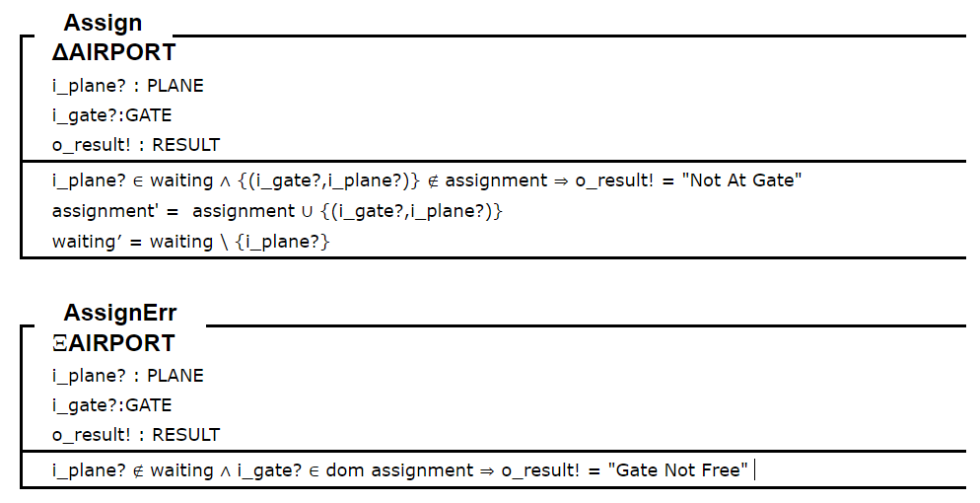

1. Plane leaving the gate LeaveTotal == Leave ∨ LeaveErr Leave records the plane leaving its gate. The assignment for plane is removed from the assigned gate.

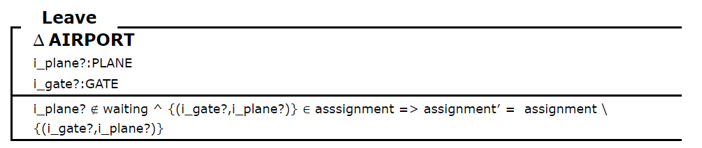

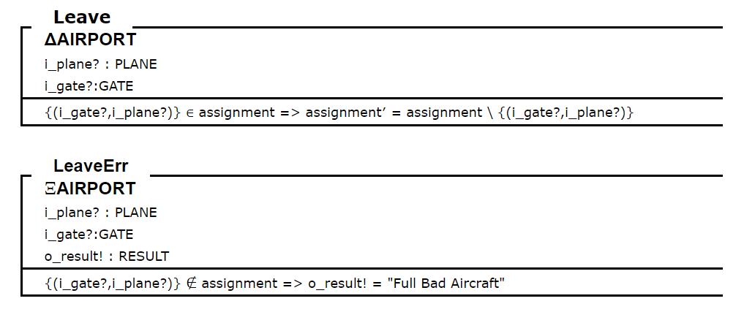

***THE END***